**Abstract**

This project focused on designing a matching circuit for a zero bias Schottky detector diode. Using lumped elements such as capacitors and inductors, we matched an input impedance of the diode to the 50 Ω transmission line. The diode used during the design process was the Skyworks SMS7630-079LF. The purpose of the design was to reach a gain of -10 dB for the S11 parameter in the matching network at an operating frequency of 915 MHz which is an FCC regulated frequency. Furthermore, that gain was required to be at least -3 dB over the bandwidth range of +/- 20 MHz.

**Introduction**

A Schottky diode is created when a metal film is connected with a semiconductor in a circuit to produce a lower voltage drop in a lower reverse bias (in our case zero bias). Figure. 1

shows the formation of Schottky diode structure showing both the metal and semiconductor parts and their rectifying junction.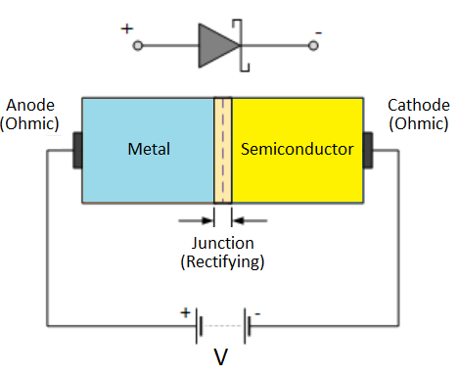

 RF zero bias Schottky detector diodes have an important role in ISM (Industrial, scientific and medical) applications.

Figure. 1 Schottky diode structure

“Some applications of Schottky diodes include rectifiers in switching regulators, discharge protection in power electronics, and rectifying circuits requiring high switching rate.” [1]

**Design & Experiment Results**

Starting with the design process, we used the ADS software to create a 1 capacitor 1 inductor lumped element design along with an SnP connected to the inductor to transform the power as Figure. 2 shows. The design looked good on paper, however when simulating on the smith chart, and generating the output, even though the gain of S11 parameter was less than -10dB  the desired bandwidth of 20 MHz between 3dB and  -3dB was not achieved as seen on Figure. 3.

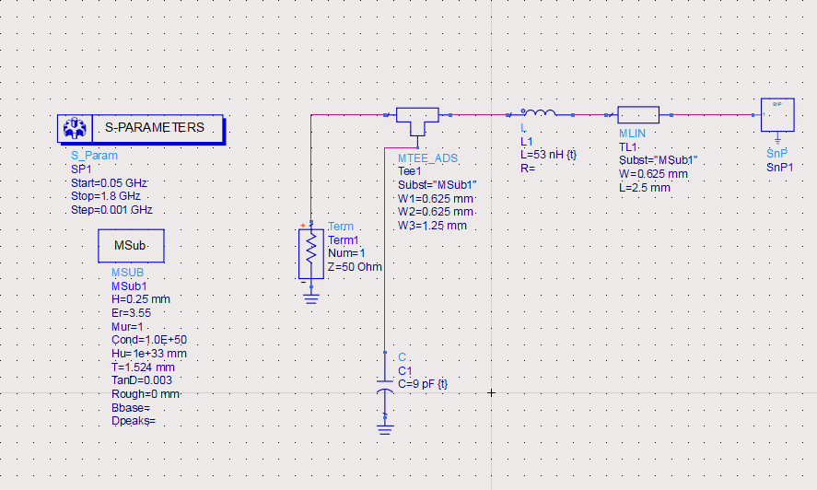

Figure. 2  1-Port SnP layout

Figure. 3 S11 gain reaches -21 dB at operating frequency but the bandwidth 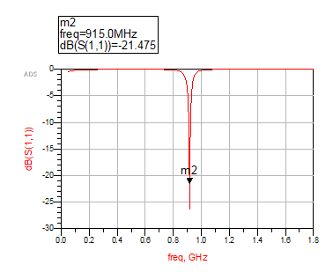

As a result, we changed the design to a 2-Port SnP and added two capacitors and two inductors to the design and used the smith chart utility to find if it is possible to match the source impedance to the load impedance. Figure. 4 illustrates utilizing the smith chart utility with the 2 capacitor - 2 inductor combination. After using the smith chart utility, we added the capacitors and inductors with the SnP representing the S-parameter given values, in addition to the 47nH  inductor used for voltage DC padding. Figure. 5 below shows the design with the capacitor and inductor after tuning and using the certain values that were provided in the capacitor and inductor kits PDFs from Dr. Chahal. [2][3]

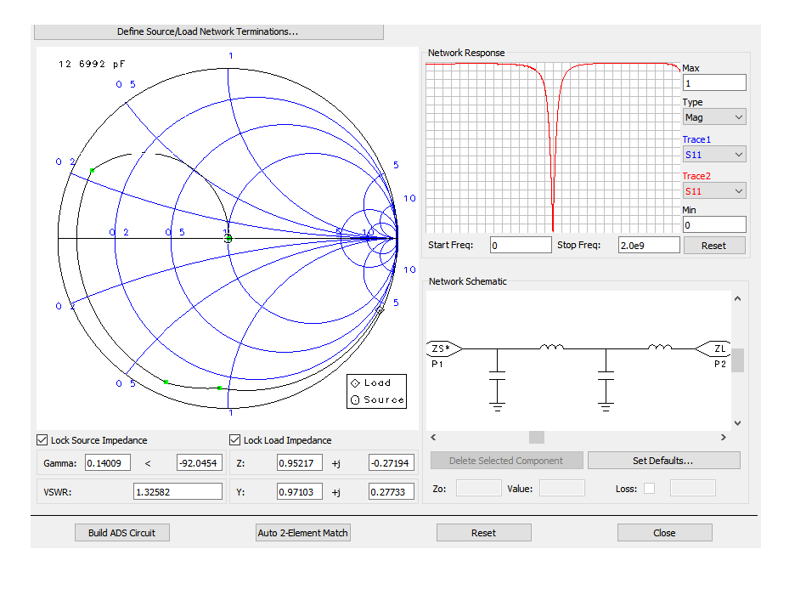

Figure. 4 Smith Chart Utility for impedance matching

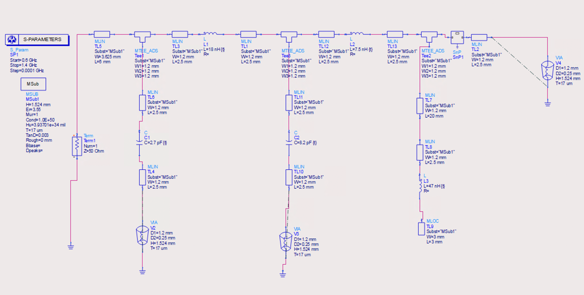

Figure. 5 Schematic design with tuned inductors and capacitors.

Simulating the design above came back with a return gain of -17.64 dB at the operating frequency of 915 MHz as Figure. 6 shows and a bandwidth of approximately 5 MHz between 3 dB and -3 dB. The bandwidth difficult variation as the professor explained was due to the design implementation. While the design satisfied the S11 to be below -10dBm, the bandwidth on the other hand was difficult to achieve given the design of the two capacitors in parallel and two inductors. The professor suggested making the smith chart circle closer to the center source impedance in an attempt to have the bandwidth differentiation from 3 dB to -3 dB to be larger than 20 MHz.

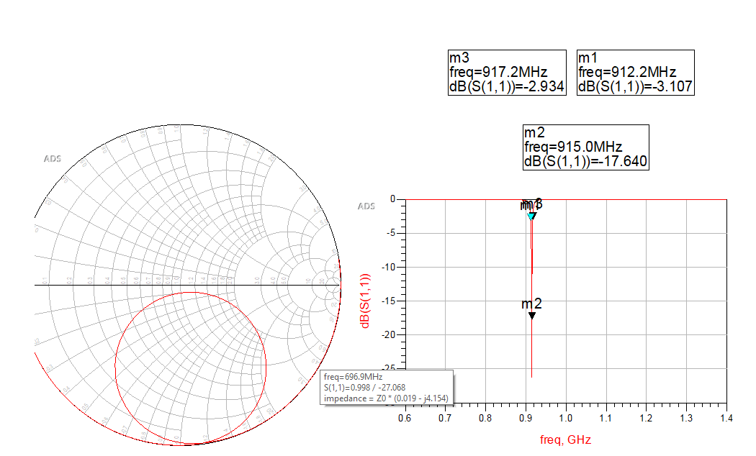

Figure.6 Design Simulation on smith chart and S11 parameter simulation (from 0.6 GHz to 1.4 GHz) graph

After that, the LineCalc tool was used to be able to synthesize the electrical properties and get the physical characteristics of the lumped elements and terminal in order to know how much space is needed between the source terminal and the other lumped elements. Figure. 7 shows the process of using LineCalc with the given physical properties of the design.

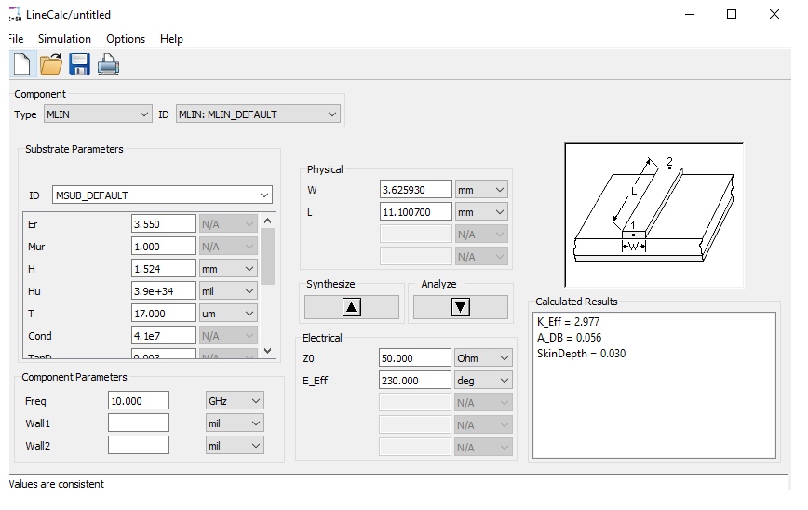

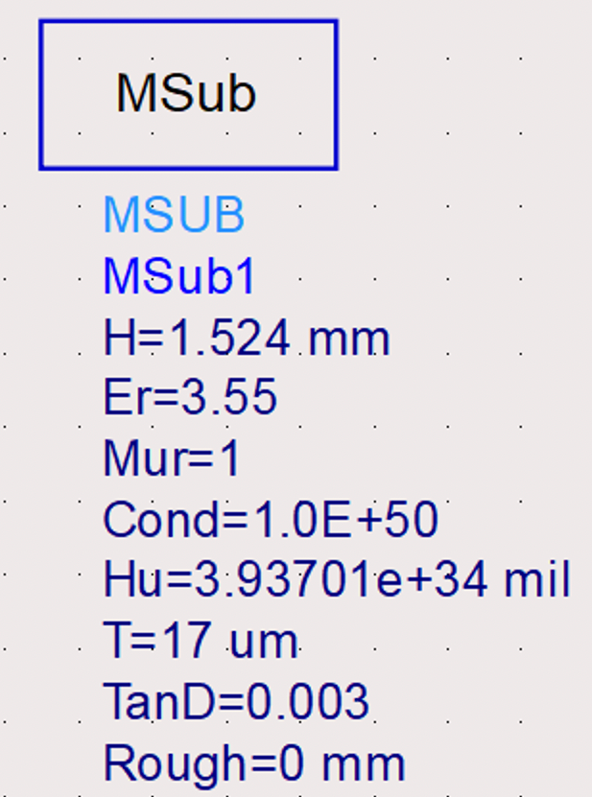

Figure. 7 LineCalc to find lengths and the physical properties of the design

After using the LineCalc utility and determining the lengths, for exporting purposes, we replaced the lumped elements with the required MLIN’s as Figure. 8 shows to export the design as a dxf file and sent it to the teacher assistant for the fabrication process, with capacitors and inductors replaced with MLINs having a length of 0.8 mm and width of 0.625mm. Furthermore, a length of 20mm was given to the MLIN before the 47nH inductor to ensure sufficient space between the DC pad and the other lumped elements as the professor explained in the lecture notes.

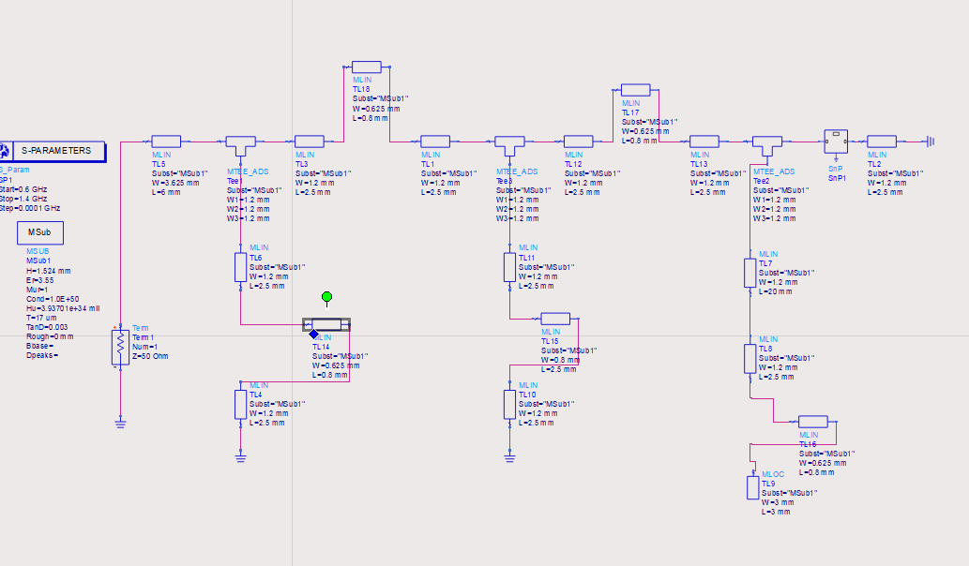

Figure. 8 Final design for export and fabrication

After fabricating the circuit, Figure. 9 below shows the fabricated circuit with the capacitors and inductors connected. The used capacitors were the 2.7 pF and 8.2 pF. The inductors used were the 47 nH for the DC pad and 18 nH and 7.5 nH.

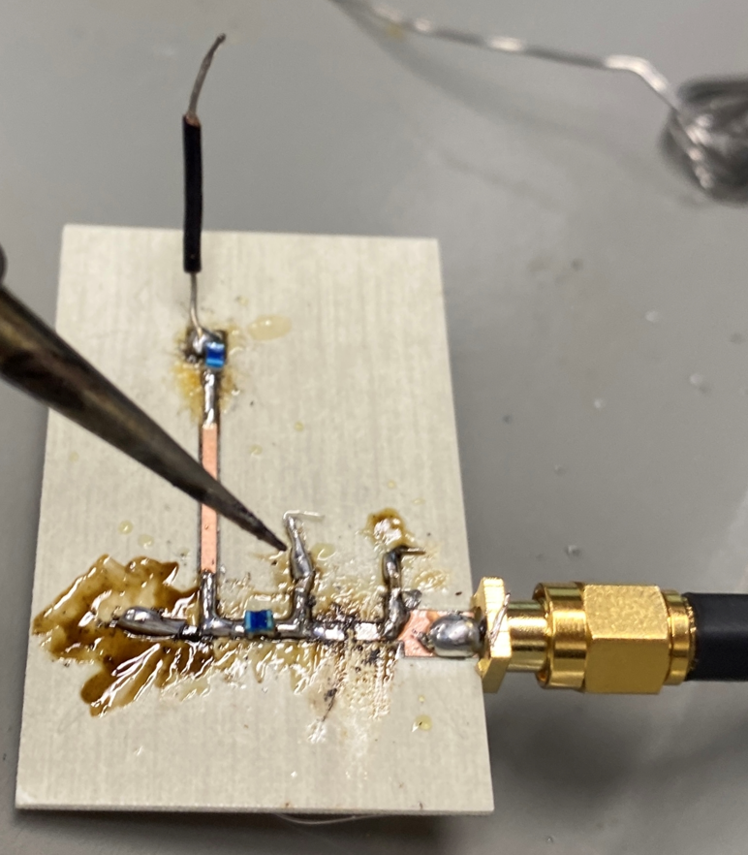

Figure. 9 RF detector Circuit after fabrication

After that, we measured the rectified voltage as a function of frequency in a range of 200 MHz from the operating frequency at fixed power of -10dBm. Table. 1 shows the different values of the measured voltages at different frequencies from the in our design.

The base frequency after fabrication shifted from 915 MHz to 692 MHz. This was due to the added wire length at the end of the design to probe for the voltage which caused a tremendous shift in our design. Furthermore,  the tolerance on the lengths of the elements was very high which could lead to variations, shifts and ultimately unexpected results. The latter wire mentioned was not and could not be included in the ADS design and therefore constructed a shift of the operating frequency.

|  |  |
| --- | --- |
| Frequency | Rectified Voltage |
| 592 | -31 mV |
| 602 | -50 mV |
| 612 | -52 mV |
| 622 | -39.6 mV |
| 632 | -25.3 mV |
| 642 | -18.5 mV |
| 652 | -21.7 mV |
| 662 | -35.2 mV |
| 672 | -45 mV |
| 682 | -43.7 mV |
| 692 | -35.6 mV |
| 702 | -26.57 mV |
| 712 | -22.3 mV |
| 722 | -24.3 mV |
| 732 | -28 mV |
| 742 | -26.4 mV |
| 752 | -25 mV |
| 762 | -28 mV |
| 772 | -28.6 mV |
| 782 | -26.7 mV |
| 792 | -22.4 mV |

Table. 1 Rectified voltage at different frequencies (+/- 100 MHz Range)

Rectified voltage was also measured at the center frequency as a function of power with different power gains from -60 dBm to 10 dBm at 10 dBm increments.  Table. 2 shows the different values of Rectified voltage at different power gain values.

|  |  |
| --- | --- |
| Power Gain | Rectified Voltage |
| -60 dBm |  |
| -50 dBm |  |
| -40 dBm |  |
|  |  |
|  |  |
|  |  |
|  |  |
|  |  |

**Conclusion**

**References**

[1] Solutions, C. P. C. B. (2020, July 1). *Do your circuits need a Schottky diode?* Cadence. Retrieved December 5, 2021, from https://resources.pcb.cadence.com/blog/2020-do-your-circuits-need-a-schottky-diode.

[2]Chahal, P. (n.d.). *Capacitor Kit*. D2L Michigan State University. Retrieved December 6, 2021, from https://d2l.msu.edu/d2l/le/content/1382769/viewContent/11578959/View.

[3]Chahal, P. (n.d.). *Inductor Kit*. D2L Michigan State University. Retrieved December 6, 2021, from https://d2l.msu.edu/d2l/le/content/1382769/viewContent/11578961/View